Human Anatomy, 8e (Marieb/Mitchell/Smith)
Chapter 1 The Human Body: An Orientation

1.1 Multiple Choice Questions

Use the diagram below to answer the following questions.

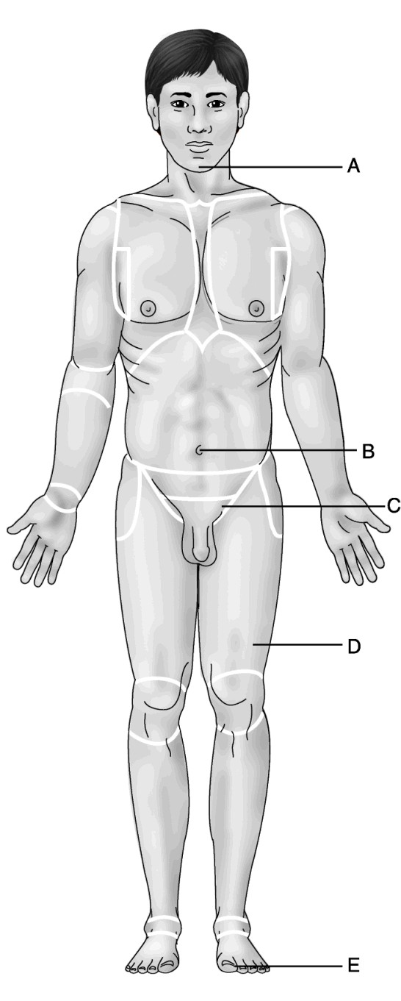
Figure 1.1

1) Which letter indicates the mental region?
A) A
B) B
C) C
D) D
E) E
Answer: A
Diff: 2 Page Ref: 7
2) Which letter indicates the umbilical region?
A) A
B) B
C) C
D) D
E) E
Answer: B
Diff: 2 Page Ref: 7

3) Which letter indicates the hallux?
A) A
B) B
C) C
D) D
E) E
Answer: E
Diff: 2 Page Ref: 7

4) Which letter indicates the inguinal region?
A) A
B) B
C) C
D) D
E) E
Answer: C
Diff: 2 Page Ref: 7

5) Which letter indicates the femoral region?
A) A
B) B
C) C
D) D
E) E
Answer: D
Diff: 2 Page Ref: 7
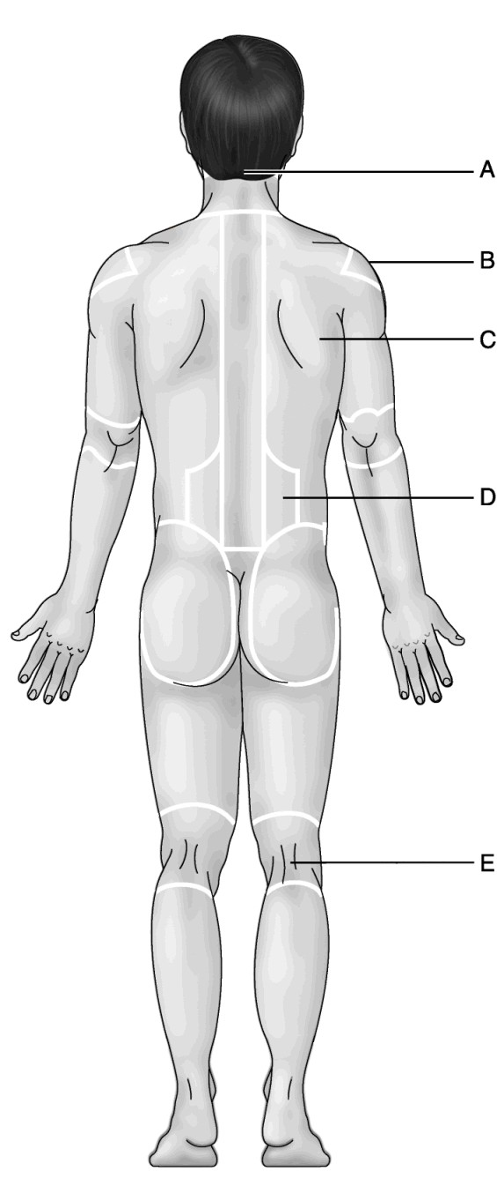
Figure 1.2

Use the diagram above to answer the following questions.

6) Which letter indicates the lumbar region?
A) A
B) B
C) C
D) D
E) E
Answer: D
Diff: 2 Page Ref: 7
7) Which letter indicates the acromial region?
A) A
B) B
C) C
D) D
E) E
Answer: B
Diff: 3 Page Ref: 7

8) Which letter indicates the scapular region?
A) A
B) B
C) C
D) D
E) E
Answer: C
Diff: 2 Page Ref: 7

9) Which letter indicates the popliteal region?
A) A
B) B
C) C
D) D
E) E
Answer: E
Diff: 2 Page Ref: 7

10) Which letter indicates the occipital region?
A) A
B) B
C) C
D) D
E) E
Answer: A
Diff: 3 Page Ref: 7

11) The chest is ________ to the abdomen.
A) superior
B) lateral
C) anterior
D) proximal
E) deep
Answer: A
Diff: 2 Page Ref: 7-8
12) The sternal region is ________ to the scapular region.
A) superior
B) lateral
C) anterior
D) proximal
E) deep
Answer: C
Diff: 2 Page Ref: 7-8

13) The knee is ________ to the foot.
A) superior
B) lateral
C) anterior
D) proximal
E) deep
Answer: D
Diff: 3 Page Ref: 7-8

14) The brain is ________ to the skull.
A) superior
B) lateral
C) anterior
D) proximal
E) deep
Answer: E
Diff: 2 Page Ref: 7-8

15) The thumb is ________ to the index finger.
A) superior
B) lateral
C) anterior
D) proximal
E) deep
Answer: B
Diff: 3 Page Ref: 7-8

16) Muscles are ________ to the skin.
A) superior
B) lateral
C) anterior
D) proximal
E) deep
Answer: E
Diff: 1 Page Ref: 7-8
17) The axillary region is ________ to the sternum.
A) superior
B) lateral
C) anterior
D) proximal
E) deep
Answer: B
Diff: 2 Page Ref: 7-8

18) The lip is ________ to the chin.
A) superior
B) lateral
C) anterior
D) proximal
E) deep
Answer: A
Diff: 2 Page Ref: 7-8

19) The eye is ________ to the occipital region.
A) superior
B) lateral
C) anterior
D) proximal
E) deep
Answer: C
Diff: 2 Page Ref: 7-8

20) The acromial region is ________ to the scapular region.
A) superior
B) lateral
C) anterior
D) proximal
E) deep
Answer: A
Diff: 2 Page Ref: 7-8

21) The gluteal region is ________ to the popliteal region.
A) superior
B) lateral
C) anterior
D) proximal
E) deep
Answer: A
Diff: 2 Page Ref: 7-8
22) The femoral region is ________ to the plantar region.
A) superior
B) lateral
C) anterior
D) proximal
E) deep
Answer: D
Diff: 2 Page Ref: 7-8

23) The heart is ________ to the sternum.
A) superior
B) lateral
C) anterior
D) proximal
E) deep
Answer: E
Diff: 2 Page Ref: 7-8

24) The pubic area is ________ to the gluteal region.
A) superior
B) lateral
C) anterior
D) proximal
E) deep
Answer: C
Diff: 2 Page Ref: 7-8

25) The umbilical region is ________ to the lumbar region.
A) superior
B) lateral
C) anterior
D) proximal
E) deep
Answer: C
Diff: 2 Page Ref: 7-8

26) The smallest living unit is
A) a cell.
B) an organ.
C) a human being.
D) a molecule.
Answer: A
Diff: 1 Page Ref: 3

27) Which branch of anatomy studies the structural changes that occur as one ages?
A) developmental anatomy
B) pathological anatomy
C) regional anatomy
D) surface anatomy
Answer: A
Diff: 2 Page Ref: 2
28) Which organ system includes the pancreas, thymus, testes, and pituitary gland?
A) integumentary
B) endocrine
C) reproductive
D) lymphatic
Answer: B
Diff: 2 Page Ref: 3 &5

29) A coronal section through the human body can
A) pass through both the nose and the occipital region.
B) pass through both ears.
C) provide mirror right and left images.
D) lie in a horizontal plane.
Answer: B
Diff: 2 Page Ref: 7, 9

30) During the process of ________, noncellular artifacts can be introduced into histology samples.
A) time
B) observation
C) staining
D) photography
Answer: C
Diff: 2 Page Ref: 14

31) The cervical region is the
A) thigh.
B) calf.
C) neck.
D) head.
Answer: C
Diff: 1 Page Ref: 7

32) The "CT" in "CT scanning" stands for
A) cut transversely.
B) Charles Thorgaard, the inventor's name.
C) correlated thickness.
D) computed tomography.
Answer: D
Diff: 1 Page Ref: 16

33) What is the function of serous membranes?
A) They act like wrapping paper to hold visceral organs together.
B) They contain gland cells that secrete mucus.
C) They halt the spread of infection.
D) They reduce friction so that viscera move freely.
Answer: D
Diff: 2 Page Ref: 12
34) The dorsal hollow nerve cord
A) develops into the brain and spinal cord.
B) is a primitive supporting rod.
C) contains the notochord.
D) is the same as the human backbone.
Answer: A
Diff: 2 Page Ref: 10

35) The main purpose of fixation is
A) to preserve the tissue.
B) to mend breaks in tissue sections.
C) to make an organ easier to section.
D) to stick tissue sections to a glass slide.
Answer: A
Diff: 2 Page Ref: 14

36) A histologist examines a specimen that has an epithelium overlying some smooth muscle. This specimen is part of
A) a molecule.
B) a cell.
C) a tissue.
D) an organ.
Answer: D
Diff: 2 Page Ref: 5

37) An example of a tissue in the body is
A) the stomach.
B) a muscle cell.
C) epithelium.
D) a macromolecule.
Answer: C
Diff: 2 Page Ref: 4

38) An example of an organ is
A) a fat cell.
B) the intestine.
C) epithelium.
D) the cardiovascular system (but not the circulatory system).
Answer: B
Diff: 1 Page Ref: 5

39) Which organ system consists of vessels that do not carry blood, but pick up fluids (and some cells) that are leaked from the blood?
A) urinary
B) endocrine
C) integumentary
D) lymphatic
Answer: D
Diff: 3 Page Ref: 4-5
40) Large molecules such as proteins are called
A) cells.
B) macromolecules.
C) multi-atom units.
D) cellular organelles.
Answer: B
Diff: 1 Page Ref: 4

41) Which organ system covers the external surface of the body, but not the internal surface of the mouth?
A) lymphatic
B) digestive
C) integumentary
D) cutaneous
Answer: C
Diff: 2 Page Ref: 4-5

42) Which organ system includes the spinal cord?
A) skeletal
B) muscular
C) nervous
D) integumentary
Answer: C
Diff: 1 Page Ref: 4-5

43) The height of an average person's trunk, from neck to perineum, is about
A) 5 meters.
B) 10 centimeters.
C) 1000 μm.
D) 1 meter.
Answer: D
Diff: 3 Page Ref: 3

44) Which statement concerning the anatomical position is FALSE?
A) The palms face anteriorly.
B) The toes point anteriorly, but the fingers point inferiorly.
C) The knees, elbow, and neck are straight (not bent).
D) The person is lying down, as straight as possible.
Answer: D
Diff: 2 Page Ref: 6

45) Bilateral symmetry can apply to objects as well as to animal bodies. Which of the following capital letters of the alphabet is not bilaterally symmetrical?
A) A
B) M
C) L
D) O
Answer: C
Diff: 2 Page Ref: 10
46) Which structure is not covered by visceral serosa?
A) lungs
B) ribs
C) stomach
D) uterus
Answer: B
Diff: 2 Page Ref: 12

47) The femoral region is the
A) buttocks.
B) hip.
C) thigh.
D) toes.
Answer: C
Diff: 1 Page Ref: 7

48) The inguinal region lies
A) anterior to the elbow joint.
B) on the anterior neck.
C) where the thigh joins the trunk.
D) on the external genitals.
Answer: C
Diff: 2 Page Ref: 7

49) The perineal region is the
A) side of the leg.
B) region between the external genitals and the anus.
C) point of the shoulder.
D) superior part of the gluteal region.
Answer: B
Diff: 2 Page Ref: 7

50) Which structure is not present in the mediastinum?
A) esophagus
B) heart
C) lung
D) trachea
Answer: C
Diff: 2 Page Ref: 11

51) A frontal plane is the same as a ________ plane.
A) midsagittal
B) transverse
C) coronal
D) sagittal
Answer: C
Diff: 2 Page Ref: 7, 9
52) Another name for the midsagittal plane is
A) parasagittal.
B) oblique.
C) coronal.
D) median.
Answer: D
Diff: 2 Page Ref: 7

53) What point or structure in the body is located farthest laterally? (Hint: Questions always refer to the body in the anatomical position.)
A) the coxal region
B) ear
C) little toe
D) tip of thumb
Answer: D
Diff: 3 Page Ref: 7-8

54) Although transmission electron microscopy is usually used for high-magnification viewing, it is certainly possible to use it at low magnification as well. That is, one can produce similar micrographs of tissues taken by light microscopy and electron microscopy at the same magnification. Even at the same magnification, however, you can easily tell the two kinds of micrographs apart. How?
A) The image in the electron micrograph is still sharper.
B) Tissue viewed by electron microscopy is colored, whereas light micrographs are always black and white (and shades of gray).
C) Tissue for light microscopy cannot be fixed (no fixation).
D) Tissue for electron microscopy cannot be sectioned.
Answer: A
Diff: 2 Page Ref: 14

55) What is the main advantage of MRI as a medical imaging technique?
A) It is safe.
B) The patient feels less pain during the procedure than with any other imaging technique.
C) It is very inexpensive.
D) It shows soft tissues very clearly.
Answer: D
Diff: 2 Page Ref: 18

56) The extremities are the same as
A) the ears.
B) the fingers and toes.
C) the limbs.
D) all structures in the head.
Answer: C
Diff: 2 Page Ref: 7
57) Which of the following pairs of organs/structures is located ipsilateral?
A) cecum : sigmoid colon
B) descending colon : spleen
C) mouth : navel
D) right lung : left lung
Answer: B
Diff: 3 Page Ref: 8

58) A physician viewing an injury to the back would look at the patient's ________ side.
A) lateral
B) posterior
C) cranial
D) ventral
Answer: B
Diff: 2 Page Ref: 8

59) The ________ body cavity contains the brain.
A) dorsal
B) ventral
C) serous
D) lateral
Answer: A
Diff: 2 Page Ref: 11

60) The roots of anatomical terminology lie mainly in
A) German and French.
B) Latin and Greek.
C) Esperanto.
D) Russian and Old English.
Answer: B
Diff: 2 Page Ref: 6

61) The ________ cavity contains the heart and lungs.
A) abdominopelvic
B) dorsal
C) thoracic
D) lateral
Answer: C
Diff: 2 Page Ref: 11

62) Hormones are regulatory proteins that are secreted by the ________ system.
A) urinary
B) endocrine
C) integumentary
D) lymphatic
Answer: B
Diff: 2 Page Ref: 4-5
63) Which organ system keeps blood constantly supplied with oxygen, removes carbon dioxide, and contains many air tubes?
A) urinary
B) endocrine
C) circulatory
D) respiratory
Answer: D
Diff: 2 Page Ref: 4-5

64) The elimination of nitrogenous wastes from body fluids is regulated by the ________ system.
A) urinary
B) endocrine
C) integumentary
D) lymphatic
Answer: A
Diff: 1 Page Ref: 4-5

65) Which structures are evidence of the vertebrate characteristic of segmentation?
A) branches of the blood vessels
B) multiple joints of fingers
C) subdivisions of the gastrointestinal tract
D) vertebral column
Answer: D
Diff: 2 Page Ref: 11

66) Which statement about visceral serosa is false?
A) It clings to the surface of organs.
B) It is continuous with the membrane that covers the outer body wall.
C) It is deep to the parietal serosa.
D) It lines the internal surface of hollow organs.
Answer: D
Diff: 2 Page Ref: 12

67) How many centimeters are there in a meter?
A) 10
B) 100
C) 1,000
D) 1,000,000
Answer: B
Diff: 3 Page Ref: 6

68) Which organ is not found in the ventral body cavity?
A) heart
B) liver
C) spinal cord
D) urinary bladder
Answer: C
Diff: 2 Page Ref: 11
69) The ankle lies ________ to the thigh.
A) distal
B) proximal
C) lateral
D) inferior
Answer: A
Diff: 2 Page Ref: 8

70) The axillary artery is found in the region of the
A) posterior surface of the knee.
B) vertebral column.
C) armpit.
D) long axis of any limb.
Answer: C
Diff: 2 Page Ref: 7

71) As an anatomical region, lumbar refers to
A) the infero-medial aspect of the back.
B) part of the lower limb.
C) the wrist.
D) the breast.
Answer: A
Diff: 2 Page Ref: 7

72) The buccal region is the
A) cheeks.
B) waist.
C) calf of the leg.
D) underside of the foot.
Answer: A
Diff: 2 Page Ref: 7

73) The popliteal region is
A) the side of the leg.
B) in the cervical region.
C) the posterior surface of the knee.
D) the inferior part of the gluteal region.
Answer: C
Diff: 2 Page Ref: 7

74) The coxal region is
A) the same as the inguinal region.
B) the skin over the "tailbone."
C) the hip.
D) the posterior surface of the wrist.
Answer: C
Diff: 2 Page Ref: 7
75) Which structure is located entirely within the right upper quadrant?
A) appendix
B) gallbladder
C) spleen
D) stomach
Answer: B
Diff: 2 Page Ref: 13

1.2 True/False Questions

1) Serous cavities include the pleural cavity.
Answer: TRUE
Diff: 1 Page Ref: 12

2) Serous cavities contain air.
Answer: FALSE
Diff: 2 Page Ref: 12

3) The peritoneal cavity is a serous cavity.
Answer: TRUE
Diff: 2 Page Ref: 12

4) EM has much greater resolution than LM.
Answer: TRUE
Diff: 2 Page Ref: 14

5) The dorsal body cavity is subdivided into a cranial cavity and a vertebral cavity.
Answer: TRUE
Diff: 2 Page Ref: 11

6) Pathological anatomy deals with structural changes caused by disease.
Answer: TRUE
Diff: 2 Page Ref: 2

7) A CT scan produces an image of a transverse section of the body.
Answer: TRUE
Diff: 2 Page Ref: 16-17

8) MRI techniques can show only images that are hard and deflect the X-rays.
Answer: FALSE
Diff: 2 Page Ref: 18

9) Ultrasound techniques are used to image a fetus because they are less damaging than other techniques.
Answer: TRUE
Diff: 2 Page Ref: 18

10) Angiography imaging is used primarily in the study of blood supply to the heart wall and brain.
Answer: TRUE
Diff: 2 Page Ref: 17
11) Most adults are between 1.5 and 2 meters tall.
Answer: TRUE
Diff: 3 Page Ref: 6

12) All vertebrate embryos have a dorsal hollow nerve cord.
Answer: TRUE
Diff: 2 Page Ref: 10

13) A transverse plane could cut the head off the body!
Answer: TRUE
Diff: 2 Page Ref: 7, 9

14) In anatomical position, the palms of the hands face medially toward the thighs.
Answer: FALSE
Diff: 1 Page Ref: 6

15) The mediastinum contains the trachea and lungs.
Answer: FALSE
Diff: 2 Page Ref: 11

1.3 Short Answer Questions

1) Describe the terms proximal and distal.
Answer: Proximal means closer to the point of attachment to the main part of the body; distal is farther from the point of attachment.
Diff: 2 Page Ref: 8

2) Describe the location of the femoral region in relation to the crural region.
Answer: The femoral region is proximal to the crural region.
Diff: 2 Page Ref: 7-8

3) Describe the location of the brachial region in relation to the pollex.
Answer: The brachial region is proximal to the pollex.
Diff: 2 Page Ref: 7-8

4) In humans, what term is synonymous with posterior?
Answer: dorsal
Diff: 2 Page Ref: 8

5) Clinicians refer to ________ anatomy when locating blood vessels to draw blood, feeling pulses, and avoiding nerves while giving injections.
Answer: surface
Diff: 1 Page Ref: 2

6) In humans, the region between the anus and the external genitals is the ________ region.
Answer: perineal
Diff: 2 Page Ref: 7

7) The olecranal region is posterior to what region?
Answer: antecubital
Diff: 2 Page Ref: 7
8) The head, neck, and trunk comprise the ________ region.
Answer: axial
Diff: 2 Page Ref: 7

9) What is the anatomical term for the thumb?
Answer: pollex
Diff: 2 Page Ref: 7

10) One could say that the forearm is ________ to the brachial region.
Answer: distal
Diff: 2 Page Ref: 8

11) Cutting the body along the median plane produces a ________ section
Answer: midsagittal
Diff: 1 Page Ref: 7, 9

12) One could describe the scalp as being ________ to the skull.
Answer: superficial
Diff: 2 Page Ref: 8

13) A ________ plane separates the body into equal left and right halves.
Answer: midsagittal (or median)
Diff: 2 Page Ref: 7, 9

14) The measurement typically used for structures within a cell is the ________.
Answer: micrometer
Diff: 3 Page Ref: 6

15) The ________ system is involved in immunity.
Answer: lymphatic
Diff: 3 Page Ref: 4-5

1.4 Essay Questions

1) Identify each of the systems that are found in the arm.
Answer: The arm contains elements of the skeletal, nervous, cardiovascular, muscular, lymphatic, and integumentary systems.
Diff: 3 Page Ref: 4-5

2) Which of the organ systems found in the arm are not found in the leg?
Answer: None
Diff: 3 Page Ref: 4-5

3) List the six unique features found in all vertebrates at some stage of their life.
Answer: Tube-within-a-tube body plan, bilateral symmetry, dorsal hollow nerve cord, notochord and vertebrae, segmentation, and pharyngeal pouches.
Diff: 3 Page Ref: 10-11
4) In adult humans, what remnants of segmentation remain?
Answer: The ribs and the vertebrae, with their segmental spinal nerves, are remnants of segmentation.
Diff: 3 Page Ref: 11

5) Select from the following techniques the best method for assessing brain function in a stroke patient: X-ray imaging, sonography, MRI. Explain why the other choices are not the best choice.
Answer: MRI is the best method of assessing brain function. X-rays do not image soft tissues well or with high resolution. They also produce only two-dimensional images of a structure. Sonography cannot be used to study the brain because sound waves cannot pass through the body skull.
Diff: 3 Page Ref: 15-19

